Next Wave Automation is celebrating the 10th Anniversary of their “CNC Shark” by building a unique chess set. This unique set will be revealed one project each month, starting with a chess board, followed by individual pieces. This month’s project is the Seahorse Knight. This project is aimed at the woodworker with moderate to intermediate skills. You will need access to V-Carve 9.0 with updates, and the tools listed below. With the V-Carve software, open the project CNC files. Carefully review all the toolpaths and make necessary changes to suit your tools and machine. The toolpaths are currently set with tool, feeds and speeds that were used in designing the original project. Don’t use them directly until you review them for your machine. You can edit the tools and change the settings to fit you own machine and requirements. It is very important to recalculate all toolpaths after making any changes. Once you have recalculated for your own machine and tools, reset the preview, and then preview all toolpaths again to visually verify the project outcome. Then create the tap file for your machine using the correct post processor. Now you’re ready to make your own Next Wave Automation 10th Anniversary Chess Set, The Seahorse Knight.

Next Wave Automation 10th Anniversary Chess Board Piece
“Seahorse Knight”
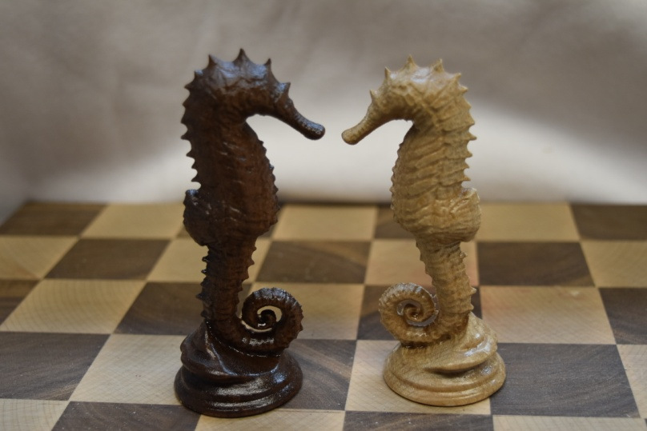
For this project we will be building a Next Wave Automation Commemorative chess piece the Seahorse Knight. You will find a material list, tool list, videos and the V-Carve files on Next Wave Automation’s Website to complete the project.

Project material list:
2 Walnut Blanks (2” x 2 3/4”x 8”)
2 Hard Maple Blanks (2” x 2 3/4”x 8”)
5/16” dowel rod
1” Bristle radial disks (120 and 240 grit)
Sanding Cord 120 grit
1” Rotary Scotchbrite disks (brown)
Polyurethane Clear
Project Tool List:
1/4” up cut Spiral straight bit
1/16” dia. Tapered ball nose bit
Project CNC Files:
Seahorse Knight.crv
Video Files:
Creating Tap files
Top Roughing and Finishing
Bottom Roughing and Finishing
Sanding and Finishing
Step 1: Creating Tap Files: 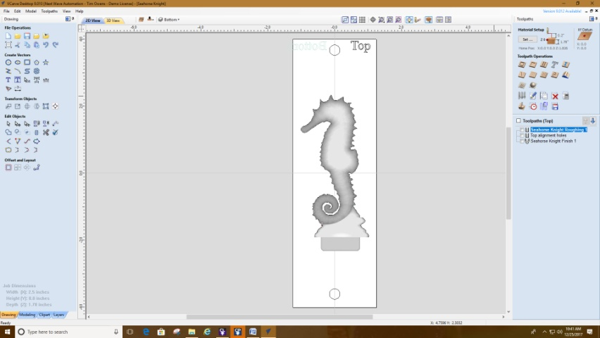
The first step in creating a tap file is to open the Seahorse Knight.crv. After opening the Seahorse Knight.crv go over to the tool path menu and save each individual tool path using your corresponding post processor file. For this project you should create five tap files. Retain the tool path names for your tap file with top and bottom attached so they match the tap files that are in the instructions. For more information please watch the video on Creation of Tap Files.

Step 2: Machining the materials:
You will need 2 pieces of walnut,
1.78”x 2 1/2“x 8“
You will need 2 pieces hard maple,
1.78”x 2 1/2“x 8“
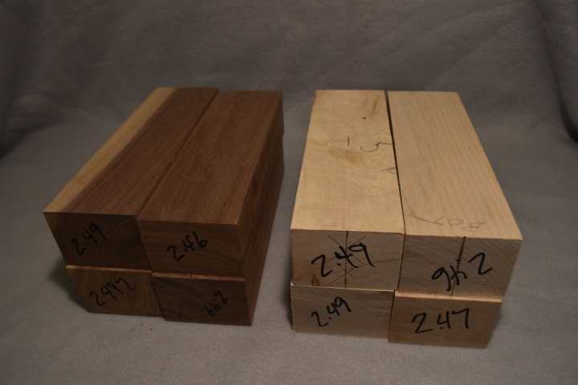
Plane down the material to 1.78“thick. Take care to make this as exact as you can. Cut the material to a width of 2.5 “. Take care to make this as exact as you can. Cut all of the material in to pieces with the length of 8”. Now that all of the pieces are machined to size mark the center of the ends and the top.

Step 3: Machining the Top of the Knight. 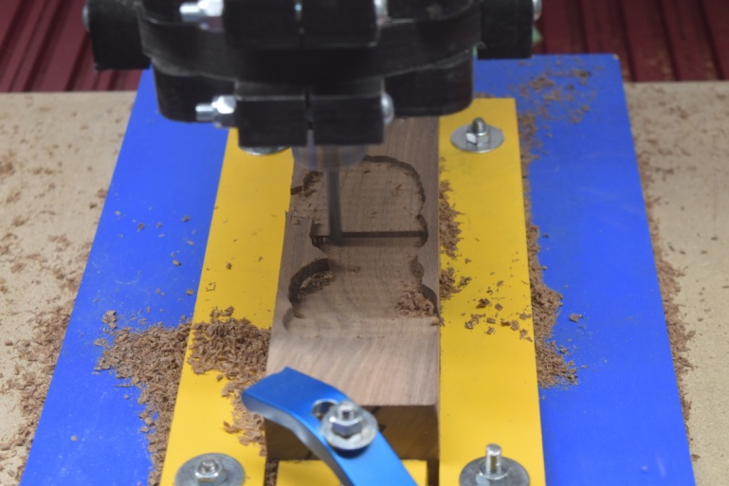
Mount the material to the centerline of the fixture. Secure in the corners with clamps as in the figure above. This is so the clamps do not get hit by the bit during machining.
Install a ¼” spiral up cut bit. Touch off the Z-axis on the “TOP of the Material” see Reference Video.
Load the Top Roughing tap file. “Top Seahorse Knight Roughing1.tap”.
Run the tap file with a router speed at 12,000 to 16,000 RPM.

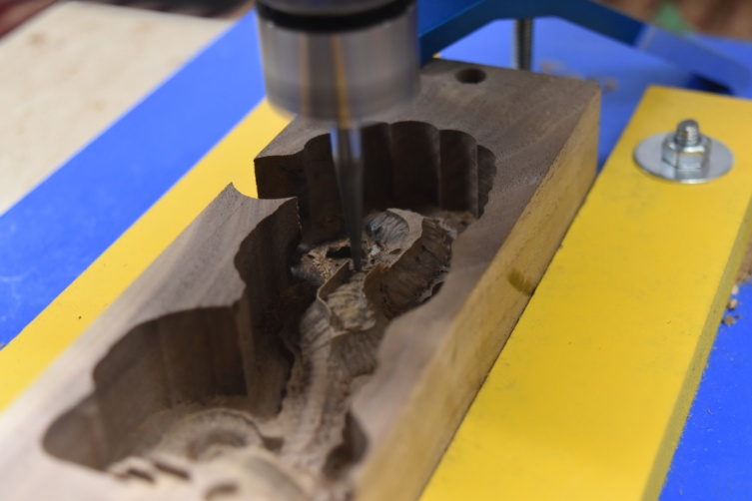
Remove all burrs from the top material. Install a 1/16” dia. Tapered ball nose bit. Touch off the Z-axis on the “TOP of the Material” see Reference Video
Load the Top Finish tap file. “Top Seahorse Knight Finish1 .tap”.
Run the tap file with a router speed at 12,000 to 16,000 RPM.
Step 4: Flipping and machining the bottom of the Knight.
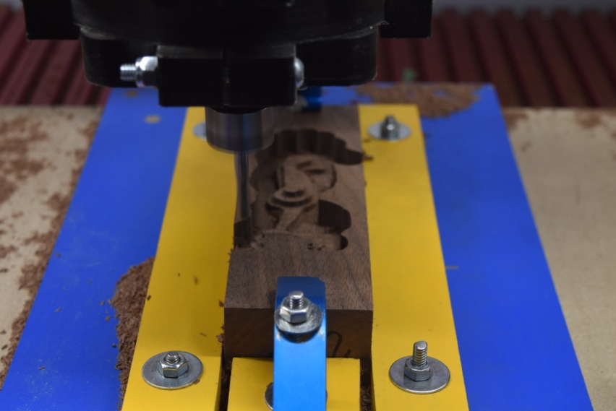
Clean the fixture of all debris. Install the 5/16” dowels in the alignment holes on the blank. Flip and install the blank in the fixture with the bottom side up, securing with the clamps. Make sure that the centerline of the blank is lined up with the centerline on the fixture.
Touch off on the fixture base, in order to assure all of our dimensions are measured off the top side of the blank which is now at the level of the fixture base. Load the bottom roughing tap file. “Bottom Seahorse Knight Roughing2. tap.” Run the tap file with a router speed at 12,000 to 16,000 RPM.
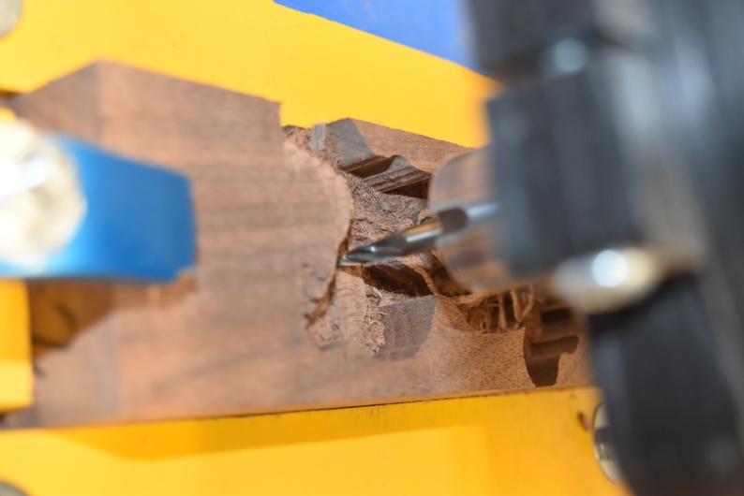
Vacuum the top of the fixture. Install the 1/16” tapered ball nose bit. Touch off on the fixture base; remember the fixture base is on the same level as the top of the blank. Load the bottom finish program. “Bottom Seahorse Knight Finish2.tap”. Run the tap file with a router speed at 12,000 to 16,000 RPM.

Step 5: Sanding and finishing the Knight: 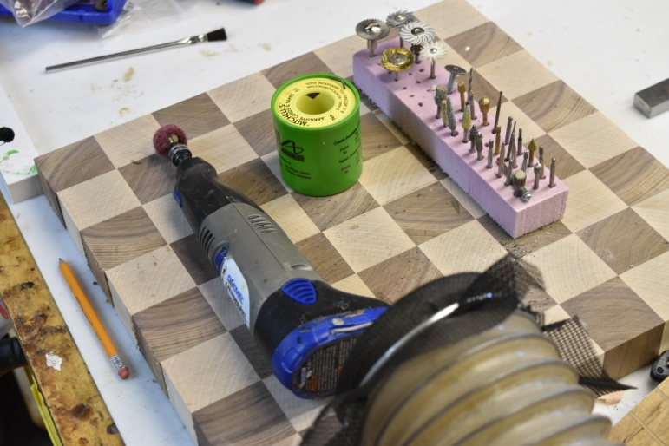
Cut the Knight free from the blank but leave one end to hold for Sanding and finishing. See Reference video.
Using the one-inch bristle disk, sand and debris the complete Knight. Get rid of all the fuzzies. Be careful not to overdo, it will take away features away on your Knight Sand everything down to with 240 grit bristle disk and sandpaper. Once you are satisfied with the Sanding and detailing of your Knight we are ready for finishing.
Step 6: Finishing the Knight:
Take all the Knights clean and prep for finish. I chose to put on three coats of polyurethane. It gives it that satiny sheen and good protection. You could finish them with glaze to bring out the highlights or in any creative way you desire. See Reference video.

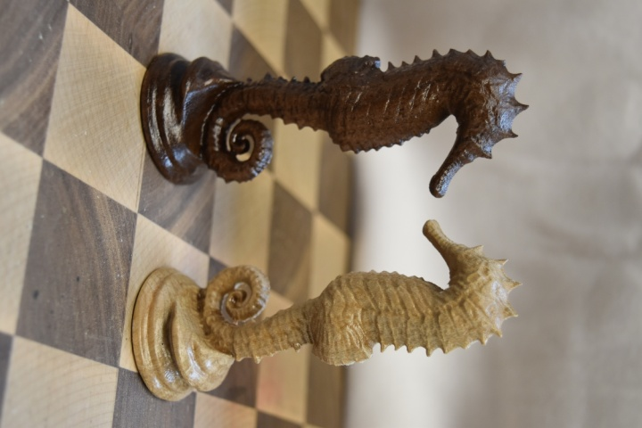
This is the Seahorse Knight Chess pieces. For a completed chess set it is necessary to have 2 hard Maple and 2 Walnut Knights.
Enjoy the creation of your “Seahorse Knights”
Next month we will add another piece to the chess set.
Rick Frazier

